# Audience Assessment Worksheet

|  |  |  |  |
| --- | --- | --- | --- |
| Group | Primary Method(s)/ Strategy(ies) | Secondary Method(s)/ Strategy(ies) | Notes |
| *Community example:*  *Families of students at Foothill Elementary School* | *Flyers in student take home folders* | *Sign at front of school*  *Announcement in Principal’s weekly email* | *Provide information in English and Vietnamese* |
| *Program provider example:*  *Zumba instructors* | *Flyers at certification class* | *Email to local licensed instructors through Zumba.com* |  |
|  |  |  |  |
|  |  |  |  |
|  |  |  |  |
|  |  |  |  |
|  |  |  |  |

# Promotions Plan Worksheet

|  |  |  |  |  |  |
| --- | --- | --- | --- | --- | --- |
| Strategy/Method | Intended Audience | Details | Schedule | Implementation Lead/Responsible Party | Budget |
| *Community example:*  *Flyers in student folders at Foothill Elementary School* | *Foothill Elementary students and families* | *500 copies needed; One-side, color copies* | *Draft content by 9/25/2018*  *Provide print flyers to school by 10/15/2018* | *Joe Smith* | *$250* |
| *Program provider example:*  *Flyers at Zumba certification class* | *Zumba instructors* | *20 copies needed; One-sided, color copies* | *Draft content by 9/25/2018*  *Provide print flyers to school by 10/15/2018* | *Joe Smith* | *$10* |
|  |  |  |  |  |  |
|  |  |  |  |  |  |
|  |  |  |  |  |  |

Example Flyer for Program Providers

**FREE FITNESS STUDIO SPACE**

**<Organization name> is opening our doors for fitness instructors to provide <free/low cost> classes to community members through a shared use agreement.**

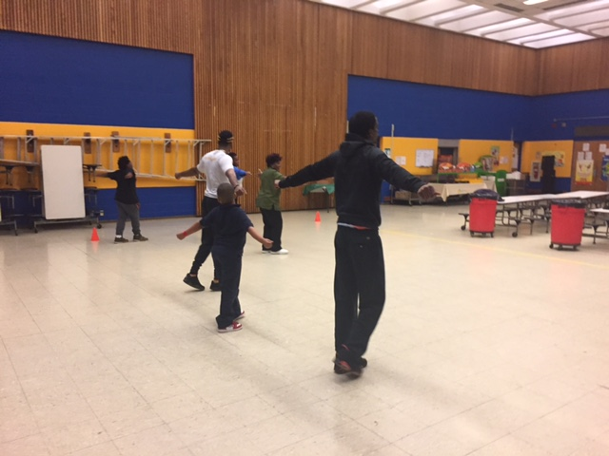

Perfect for:

Dance

Zumba

Aerobics

Yoga

And more!

<Insert details of space like square footage/capacity, special features>

Space is available on <days of the week> from <time> to <time>.

Contact <name> at <method> to learn more about the opportunity and visit our space.



*Made possible with funding from the Centers for Disease Control and Prevention.*

# Example Ads for Program Providers

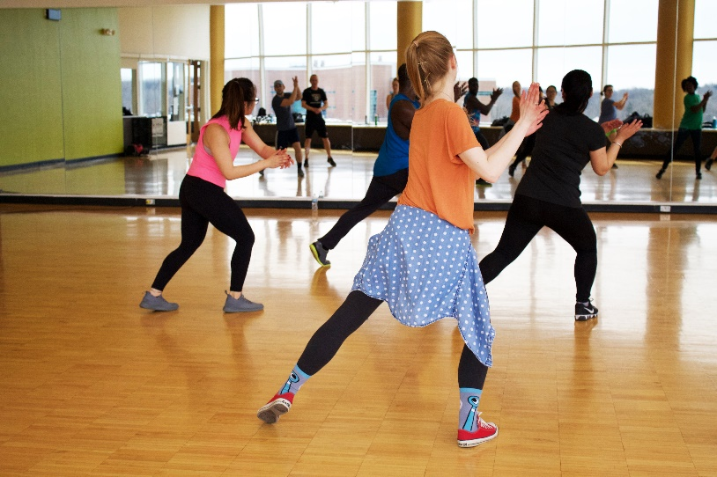

**FREE FITNESS STUDIO SPACE!**

<Insert details of space like square footage/capacity, special features>

Space is available on <insert days and times>

Contact <name> at <method> to learn more about the opportunity and visit our space.

*Made possible with funding from the  
 Centers for Disease Control and Prevention.*

FREE PARK SPACE FOR OUTDOOR CLASSES!

Organization name> is opening our doors for fitness instructors to provide <free/low cost> classes to community members.

<Insert details of space like square footage/capacity, special features>

Space is available on <days of the week> from <time> to <time>.

Contact <name> at <method> to learn more about the opportunity and visit our space.  
  
*Made possible with funding from the Centers for Disease Control and Prevention.*

# Example Social Media Posts for Community Members

***Zumba Workshops in Orange Cove***

Thanks to an agreement between the City of Orange Cove and the Kings Canyon Unified School District, Cultiva La Salud is happy to announce that Zumba classes are now available for residents of all ages and skill levels, twice weekly. This is a great opportunity to improve your health, develop healthy habits and live active lifestyles. The Zumba classes are free of charge and are taking place at McCord Elementary at 5pm every Tuesday evening and at Citrus Middle School at 6pm every Thursday evening.

Don’t miss out on the fun. Get fit while listening and dancing to upbeat Latin music.

***Free YOGA at the Orange Farmer's Market***

SunSpark Yoga is back at the Orange Home Grown Farmers & Artisans Market this Saturday 6/2/18 with our FREE All Levels/All Ages Yoga class taught by Renee Schwan Kid's Yoga class is 10:45-11:30am. Hope you can join us!

No pre-registration required. Bring a yoga mat and a friend!

# Example Flyers for Community Members

*Made possible with funding from the Centers for Disease Control and Prevention.*

Program name

For more info, contact:

Important details

Registration info

Date & time

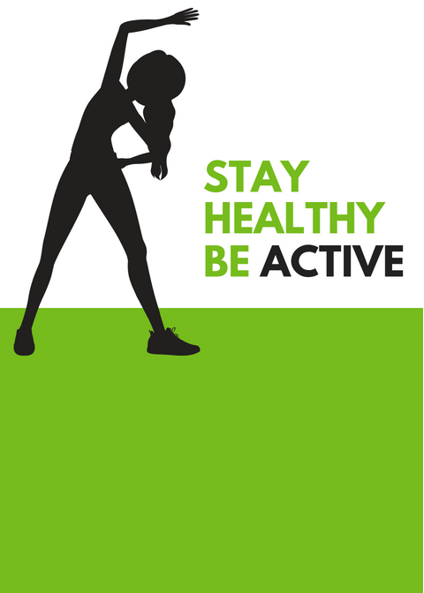

*Made possible with funding from the Centers for Disease Control and Prevention.*

2323 Main Street

Euclid, OH 232323

Register: website.com

|  |  |
| --- | --- |
| **Date & Time** | **Class Type** |
| Tuesdays 6-7 pm | Stay fit aerobics |
| Thursdays 6-7 pm | Stay fit aerobics |
| Saturdays 10-11 am | Family Zumba (all ages welcome!) |
| Sundays 1-2 pm | Seniors rock the mall walk |
|  |  |

Cuyahoga Mall Summer Classes

May-September

**Only $5**

**per class!**

# Example Ads for Community Members

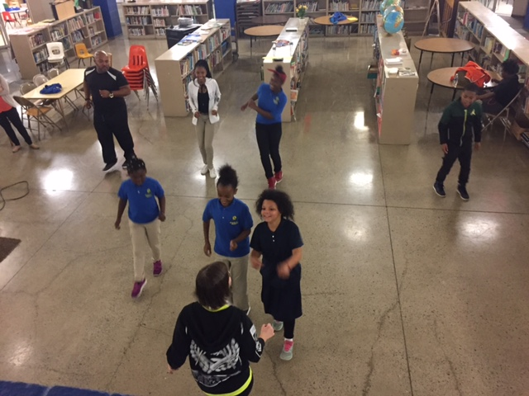­

All ages welcome

Free Zumba classes!

May-September

Free Zumba classes

Location name

Date and time

Details

Contact info

*Made possible with funding from the   
Centers for Disease Control and Prevention*

**FREE FITNESS CLASSES!**

Location name

Address

Every Monday | 6-7 pm

Every Thursday | 7-8 pm

For more information contact:

*Made possible with funding from the   
Centers for Disease Control and Prevention.*



Live active



# Example Radio Ad Script

*Radio ad script for Zumba (60 second)*

I’m here to let you know that HIP-Cuyahoga is working hard every day to create new opportunities to be healthier. One of the ways is by working with community partners to open their doors to become #healthmattershere facilities. Schools, churches, and community centers throughout Cuyahoga County have pledged to help the community to get healthier and more active by opening their doors to host healthy activities. Classes such as Zumba, Yoga, and boot camp fitness are offered for free or low cost at various #healthmattershere sites all around town. Visit HIPCuyahoga.org or call 216-309-2447. That’s 216-309-2447(CHIP) for site locations and a calendar of events and programs. Health Improvement Partnership or HIP-Cuyahoga is a group of over 100 organizations and people, just like you in Cuyahoga County who care about health. What to get involved? Contact us to help transform your community. Visit HIPCuyahoga.org or call 216-309-2447. Program schedules are subject to change.