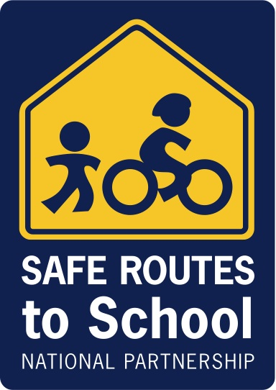

October 19, 2011
SRAM Bicycling Webinar: "Non-profit Advocacy and Safe Routes to School"
CHAT REPORT

Safe Routes to School National Partnership Staff:
- Dave Cowan
- Robert Ping

Presenters:
- Dan Grunig, Executive Director, Bicycle Colorado
- Jeremy Grandstaff, Membership Services Director, Alliance for Biking and Walking
- Sarah Shipley, Director of Marketing and Communications, BikeWalk-KC (Kansas City)
Robert Ping from SRTS National Partnership:
Hi Stephen, are you involved in SRTS in SF or Marin?

Stephen Bingham from San Francisco:
No, not yet. this is new. to know about me, go to www.sylviabinghamfund.org. that's my daughter

STACY REVAY from NAPLES, FLORIDA:
Volunteers are the best resource to a community

STACY REVAY from NAPLES, FLORIDA:
Walking School Busses going strong in Collier County, Florida

Darla Mitchell from Sky City Community School:
Our students are not allowed to walk or ride bike to school but encourage to ride bus. And can we download all this information?

Eric Bunch from Kansas City, MO: Federal rate for volunteer time is $20.20 I believe.

Eric Bunch from Kansas City, MO: It might actually just be $20.00

STACY REVAY from NAPLES, FLORIDA: national safe routes to school website is phenomenal

Safe Routes to School National Partnership: Hi Darla - you can obtain materials for this webinar at our website: www.saferoutespartnership.org, and go to the Media Tab

Nadji Kirby from Montgomery County Dept. of Transp: The independent sector values volunteer time at $21.36, if you go to their website they have actual values per state

Eric Bunch from Kansas City, MO: Great! Thanks!

Robert Ping from SRTS National Partnership: BFC is the League of American Bicyclists "Bicycle Friendly Community" designation. It is awarded to communities (and even states) that have implemented programs, infrastructure and polices that support bicycling: http://www.bikeleague.org/programs/bicyclefriendlyamerica/communities/

Meghan Grace Cochran from Grand Rapids, MI: Are there any resources online for starting a Paint the Pavement program in your town? GR has been very good at developing ovearll bike infrastructure and Complete Streets, but the advocacy hasn't been extended to children

Meghan Grace Cochran from Grand Rapids, MI: It's a very good idea

Jess Mathews from Columbus, Ohio: Meghan, can you explain a bit more the Paint the Pavement? Haven't heard that phrase

Mari Lynch from Monterey, CA: In Monterey Bay tri-county region, San Benito County partnered with Monterey Bay Unified Air Pollution Control District to create, in Spanish and English, SRTS brochures and maps for every school in San Benito County. http://sanbenitocog.org/SRTS.php Sampling of other SRTS Spanish resources here: http://marilynch.com/blog/resources/en-espanol

Tracy Moody from Potsdam NY: I could not understand what Sarah said about the free media? Can we repeat?

sarah shipley from Kansas City, MO: local CVB's have free resources

Tracy Moody from Potsdam NY: CVB? I am new to this

Stephen Lassiter from Tulsa, OK: Local Convention & Visitor's Bureaus
Tracy Moody from Potsdam NY: OK thank you!

Eric Bunch from Kansas City, MO: I think that is convention and visitors bureau

Meghan Grace Cochran from Grand Rapids, MI: PtP was a program in Kansas City that the last speaker was discussing; postcards were offered around the city for people to write personal letters about active transportation to the mayor

Meghan Grace Cochran from Grand Rapids, MI: http://bikewalkkc.org/paint

Mary Cone from Chapel Hill: Do you know if many areas in the USA use the SRTS program as part of the larger Transportation Demand Management (TDM) prrogram? And if so where and how?

Meghan Grace Cochran from Grand Rapids, MI: Like I mentioned earlier, GR//MI has been very good with the complete streets implementation, we just need that 'extra push' and more advocacy for children

Sara Cartee-Kennedy from Oviedo, FL: You noted that Colorado is the top State for bike/walk friendly legistation, is there a resource for other state rankings?

Sybil Cherian: Thank you for the wondeful presentation. Speakers were excellent!

Safe Routes to School National Partnership: Sybil, thank you for joining us! We'll be sending a survey to obtain feedback in the next few days

Robert Ping from SRTS National Partnership: The Alliance for Bicyclind and Walking puts out a benchmark report that listst every state.

Mark Haber from Pinellas County: Thank you!

Everett Hauser from San Diego, CA: Ess-Ram

