Sample Walking School Bus Route Map

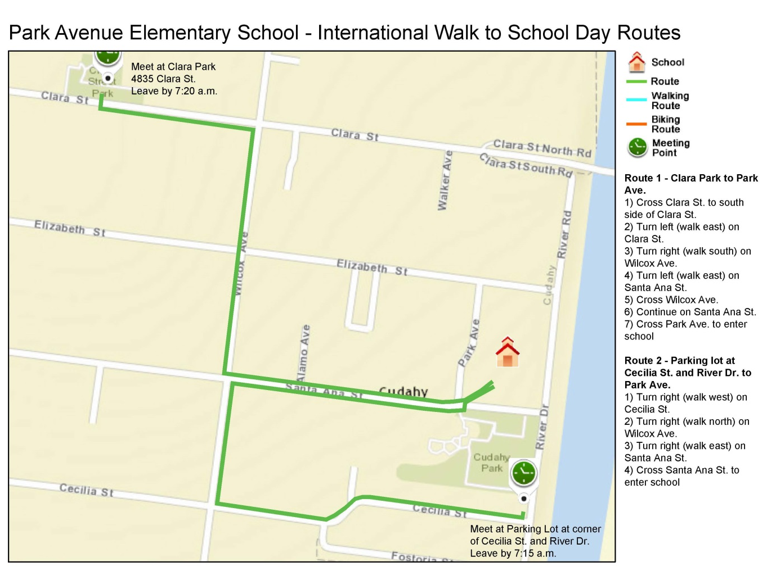

Image Source: Let’s Walk Together! Walking School Bus Training Manual Resources, Los Angeles County Department of Public Health.

